[E128] Mash temperature switch

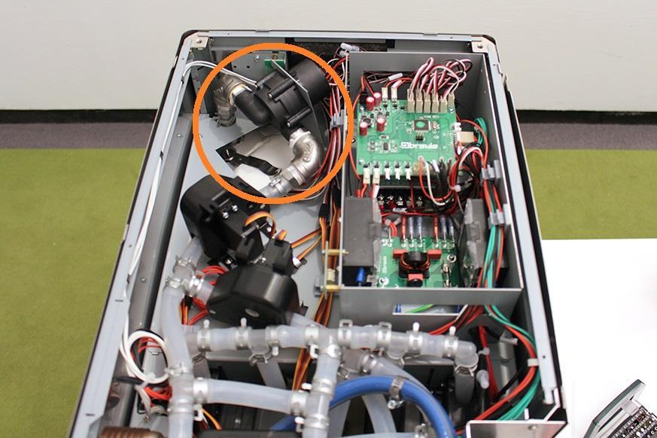

Remove the cable tie from the pump.

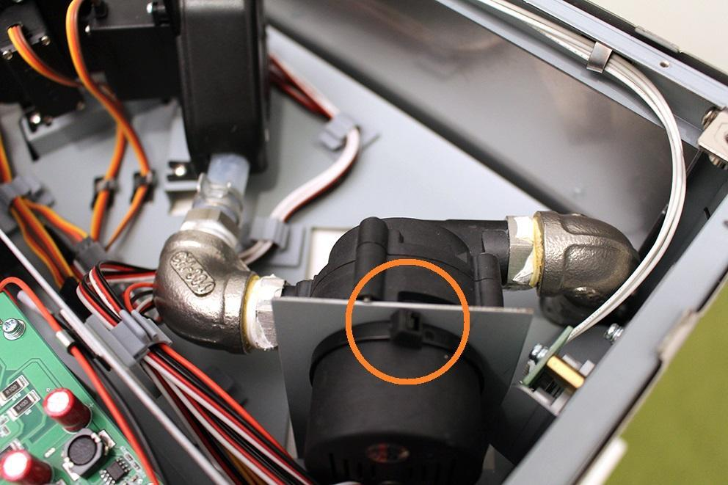

Loosen the indicated screws and remove the valve from the original position.

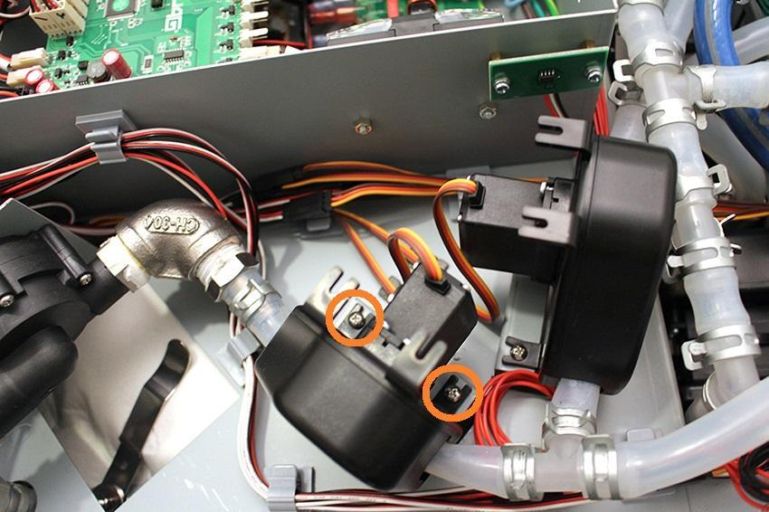

Remove the hose clamps from the fitting.

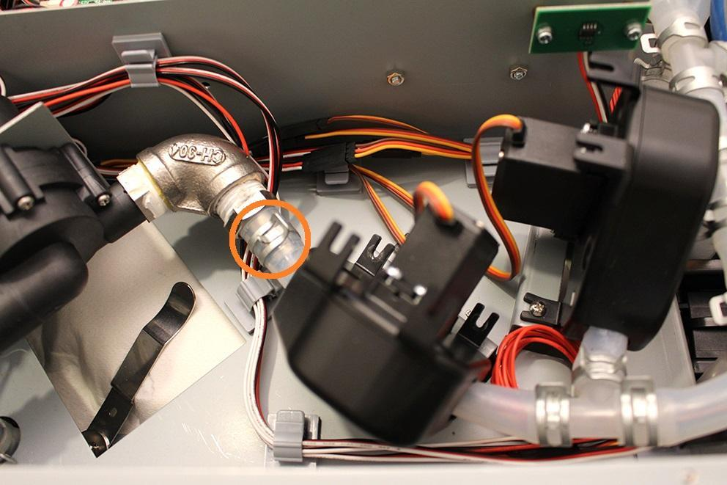

Remove the silicone tube from the fitting.

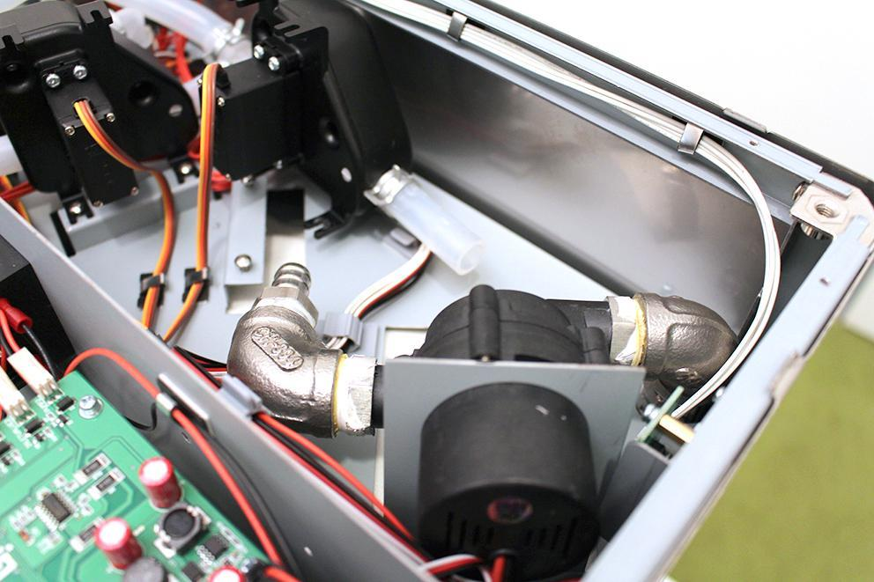

While you keep the indicated hose clamp tight, you can pull off the pump from the silicone tube by rotating the pump around its axis.

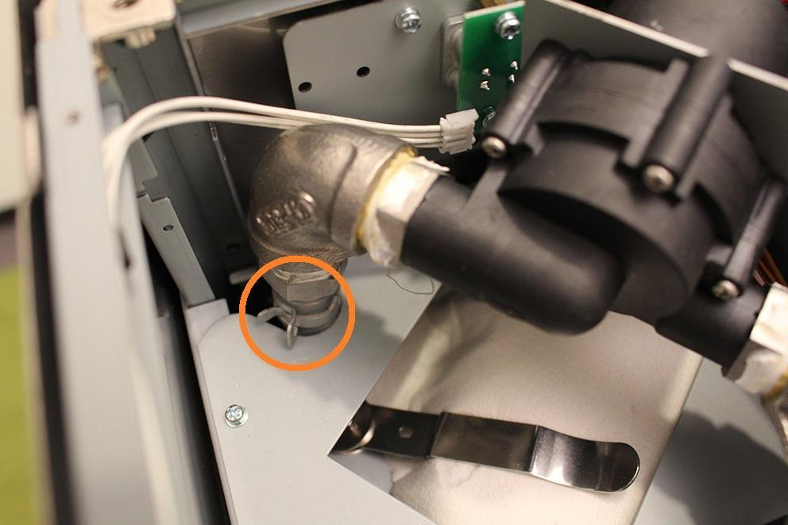

Remove the hose clamp from the interior of the machine.

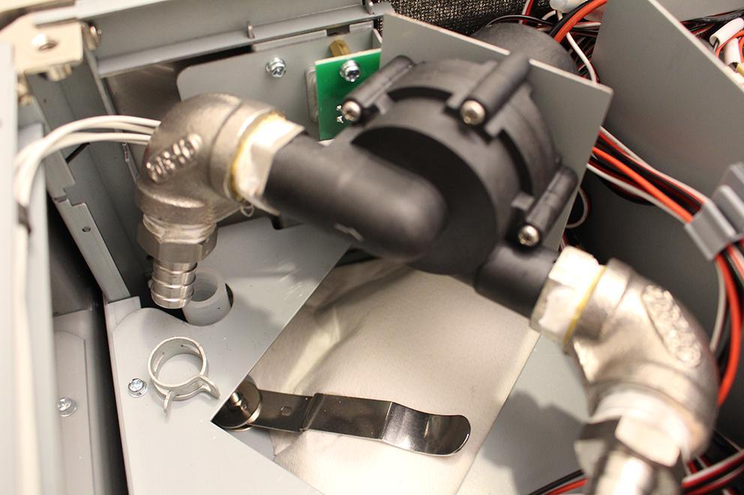

This is the plug of the pump.

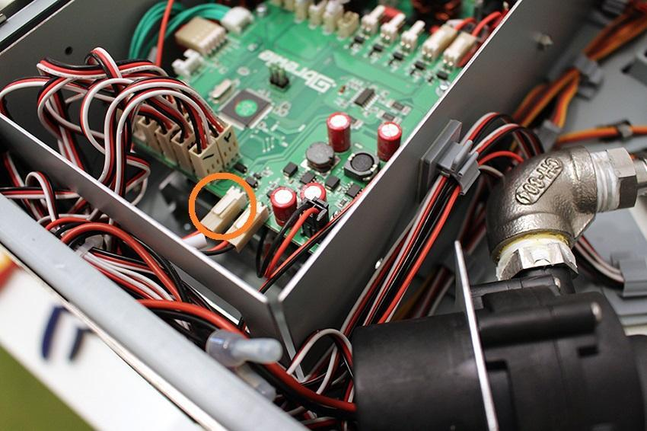

Pull it off and out of the cable hole.

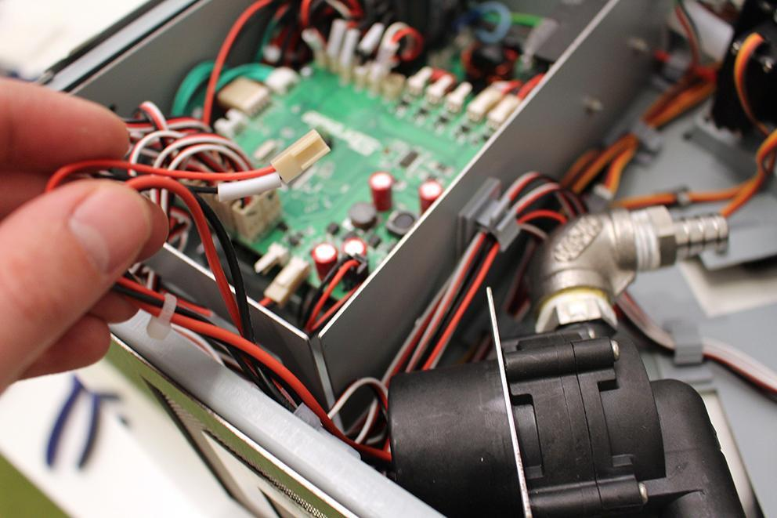

Now you can remove the pump.

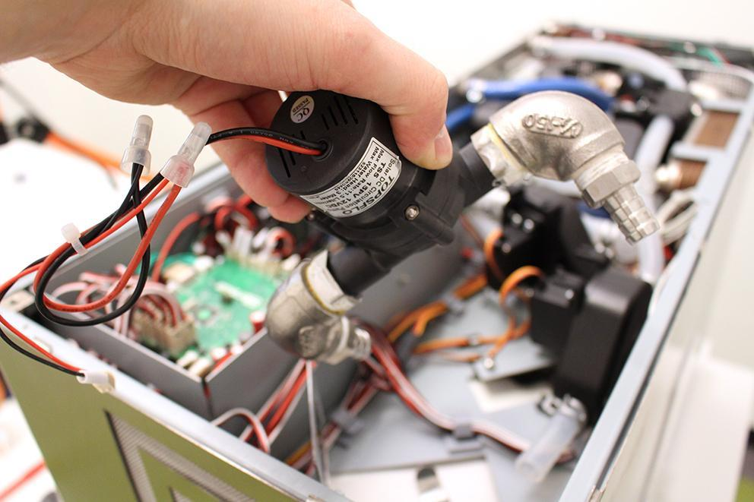

The plug of the button.

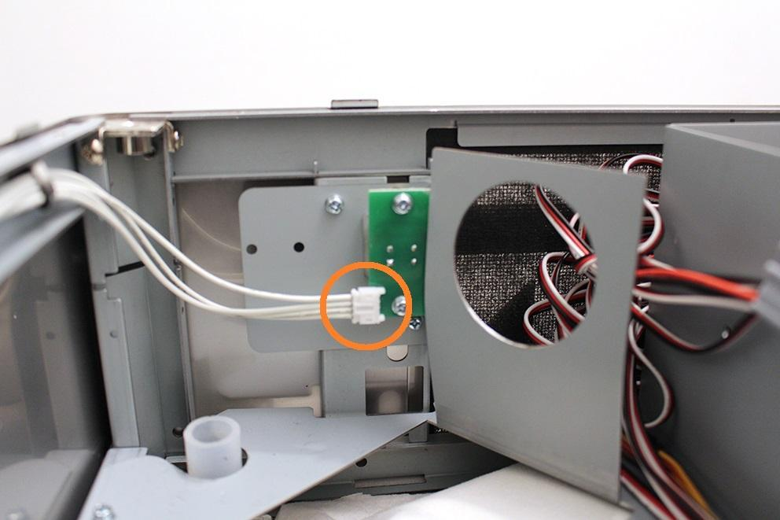

Remove the button plug and unscrew the indicated screws.

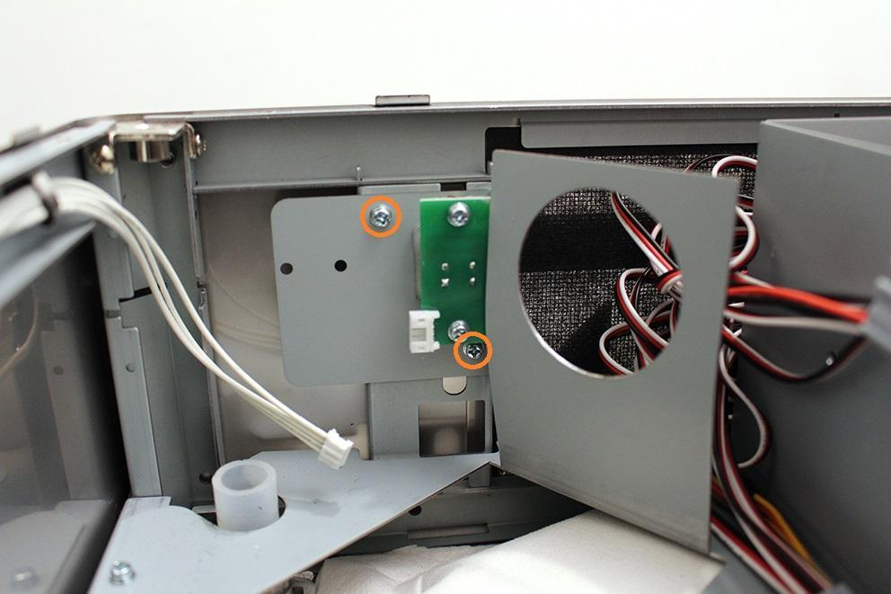

Now you can remove the button unit.

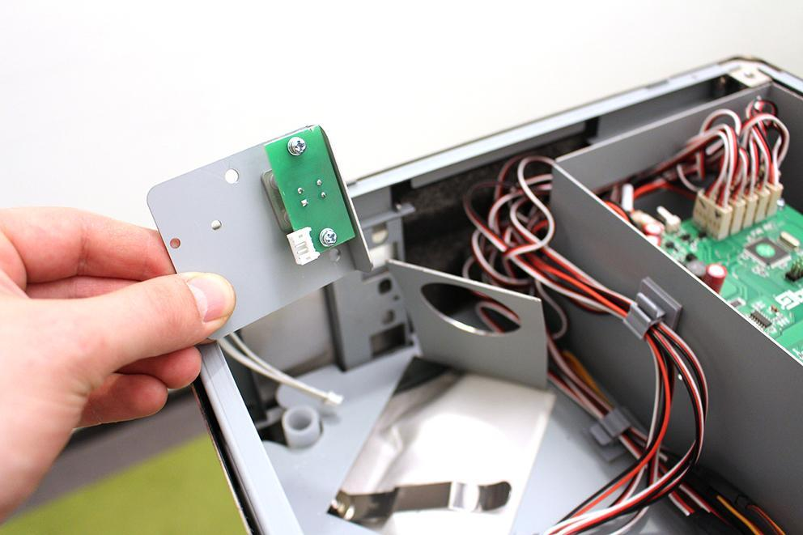

Remove the 4 indicated screws.

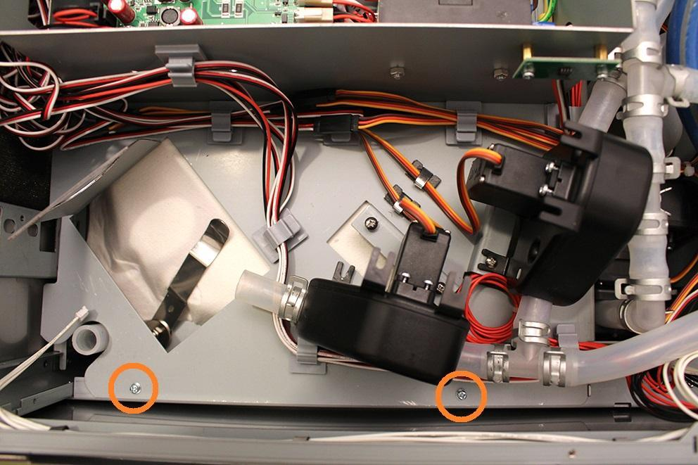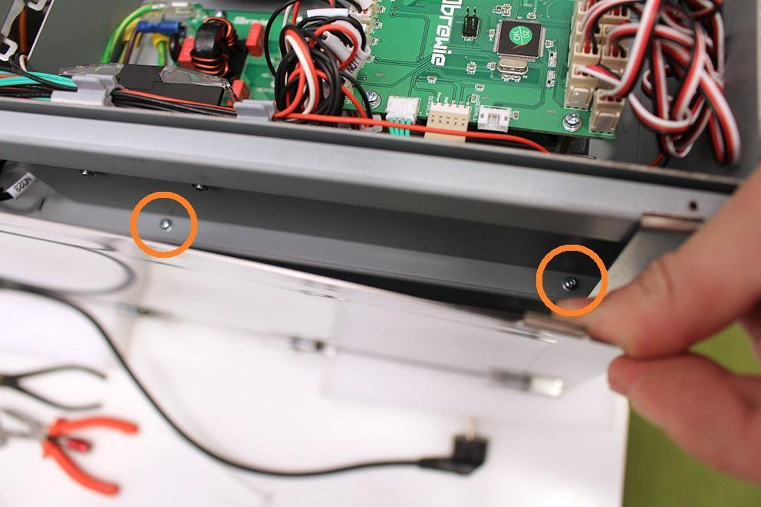

Remove the indicated hose clamps and silicone tubes from the fittings.

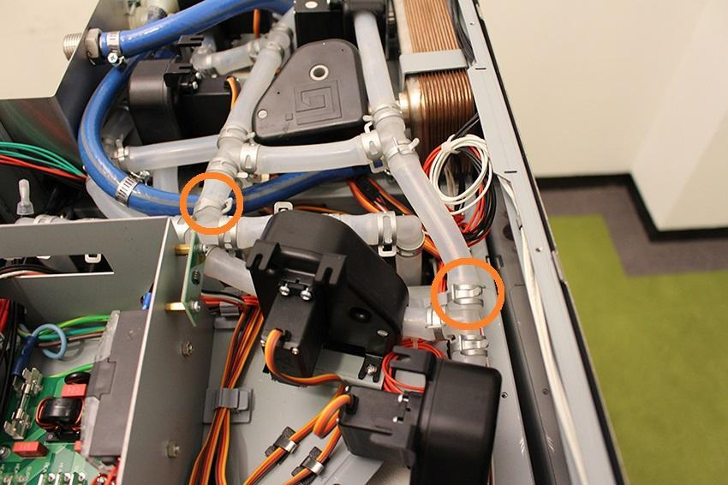

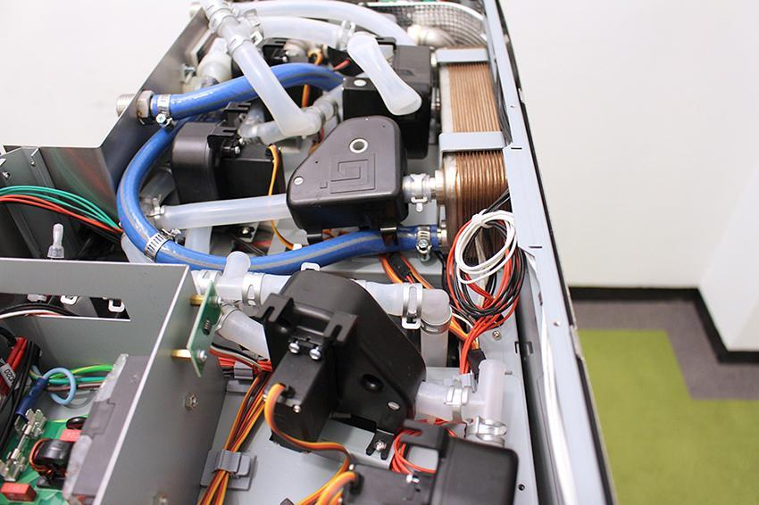

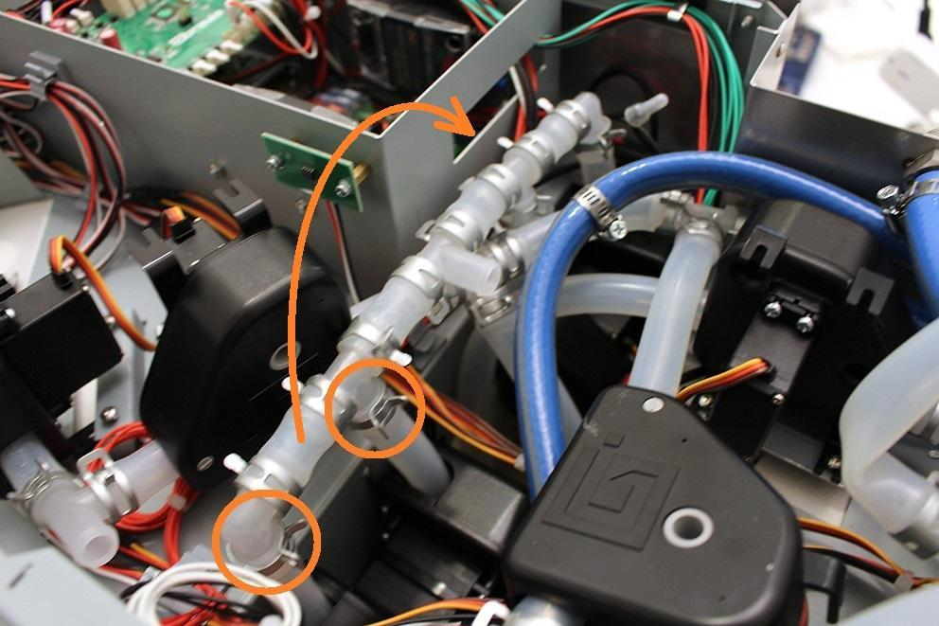

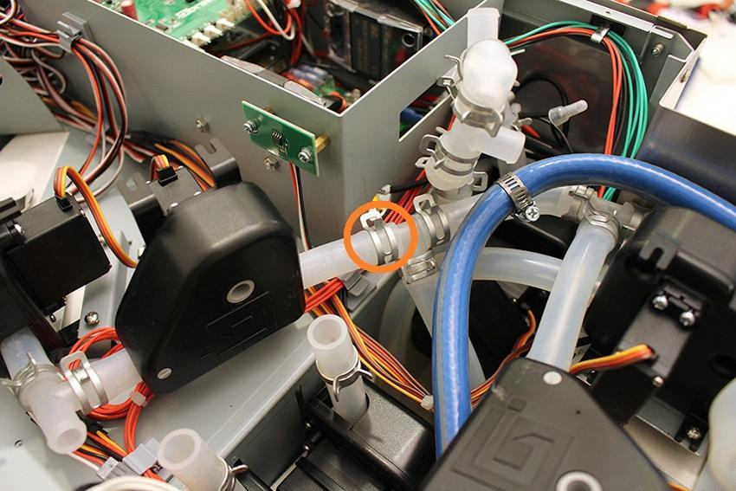

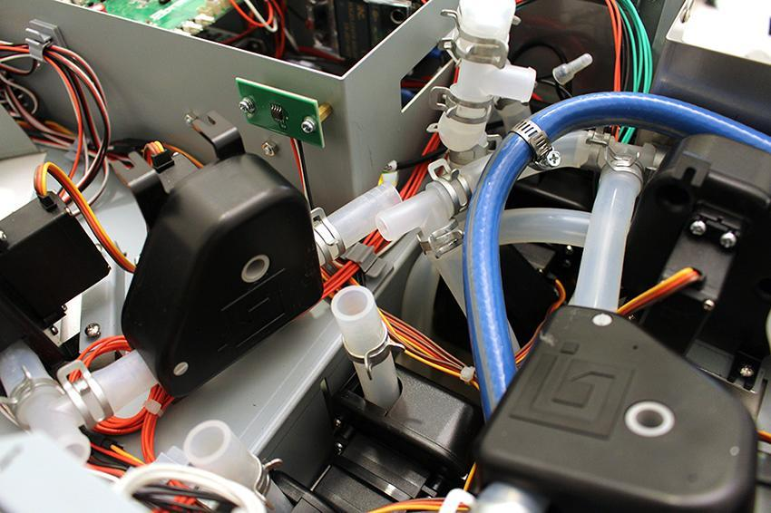

The cable of the temperature sensor.

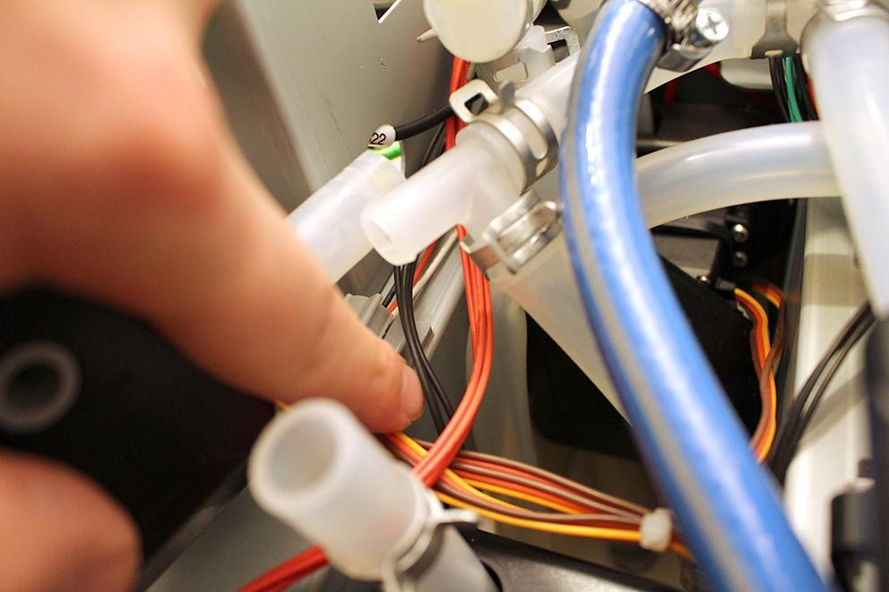

Do not disconnect, only loosen the cable of the temperature sensor. Avoid to strain the cable!

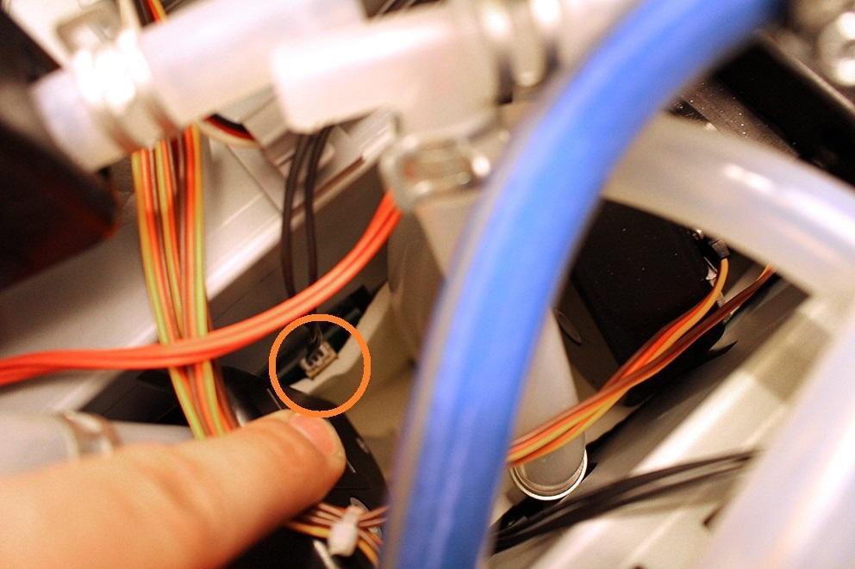

Remove the cable of the temperature sensor from the cable clips.

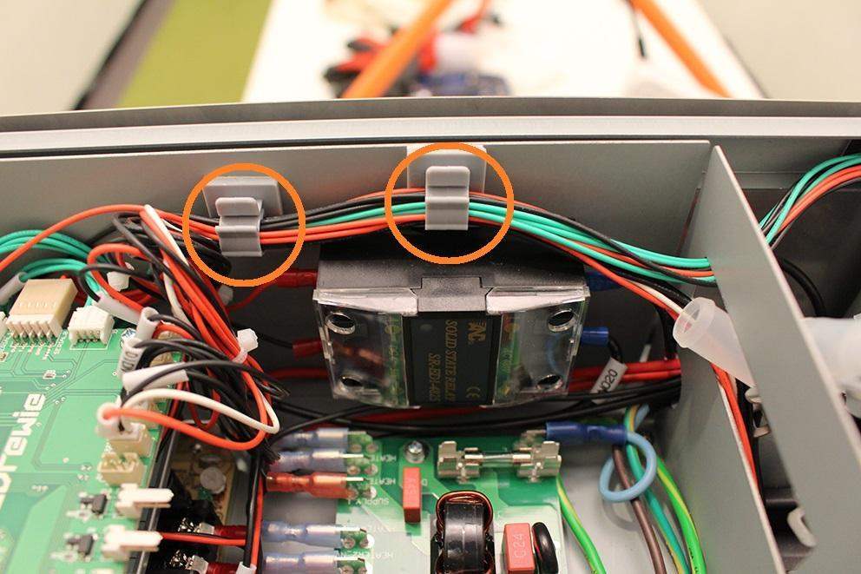

Now you can lift the assembling plate.

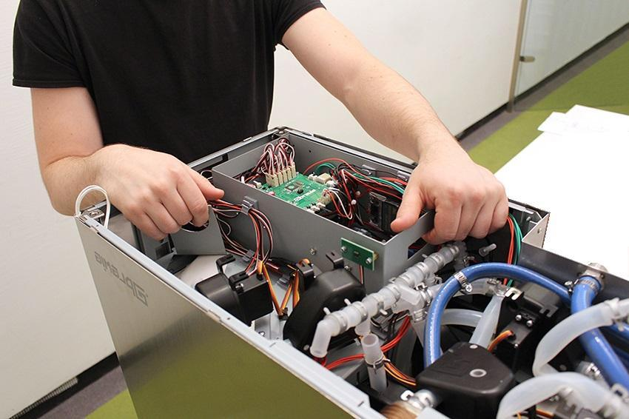

While you lifting up the assembling plate, it might stuck in some spots.

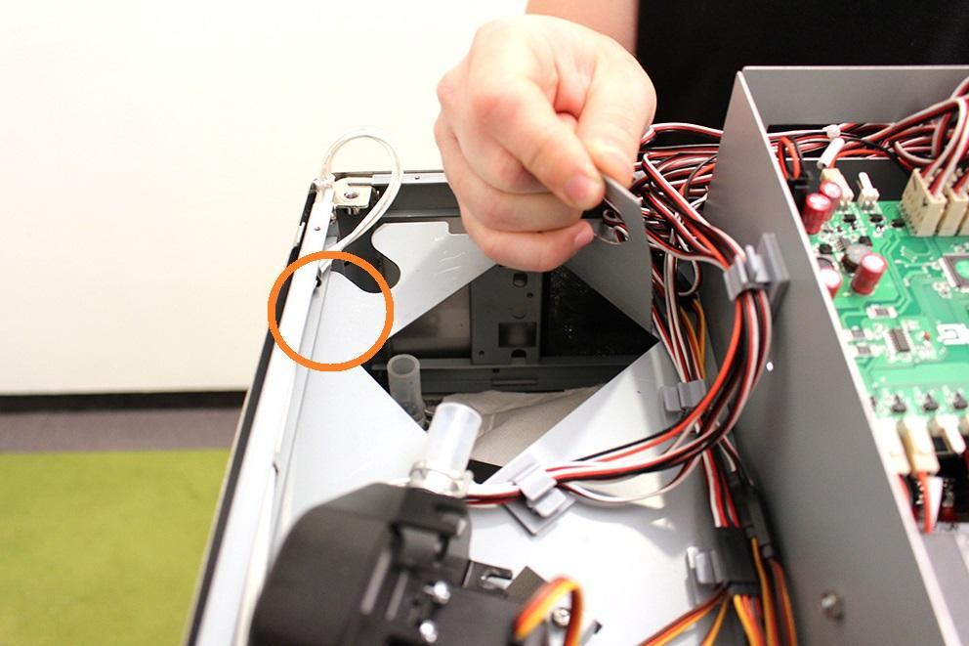

Be careful with the cables while lifting up the assembly plate!

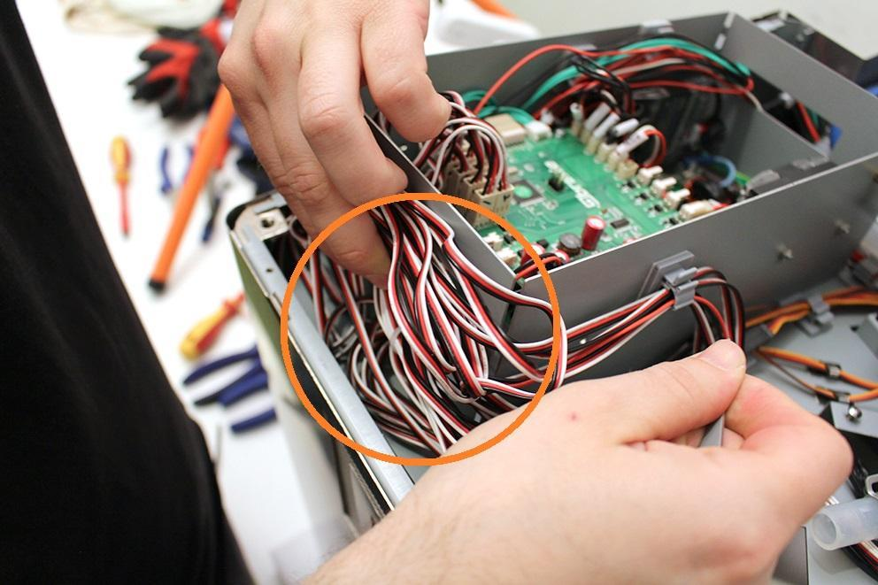

Lift the assembly plate with the following movement.

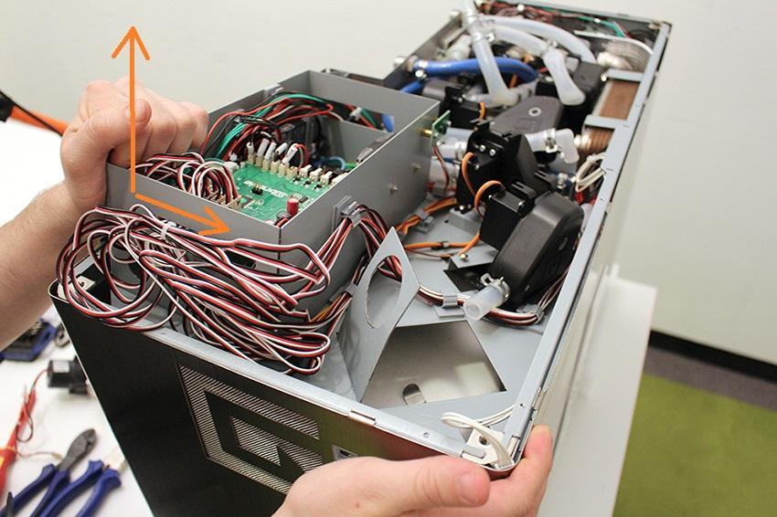

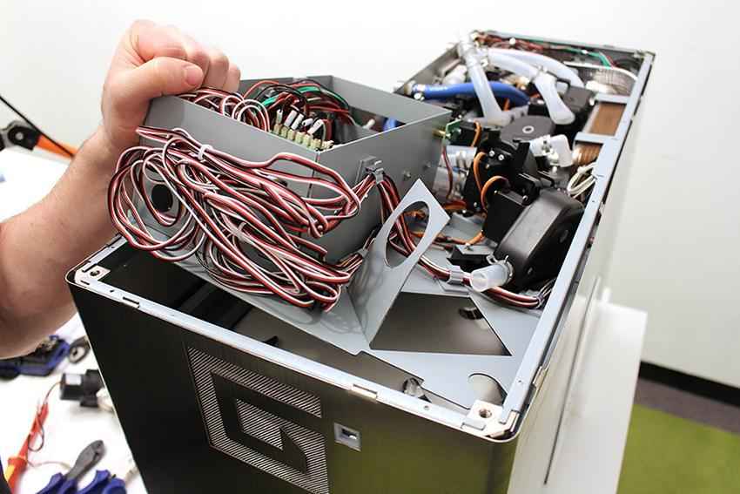

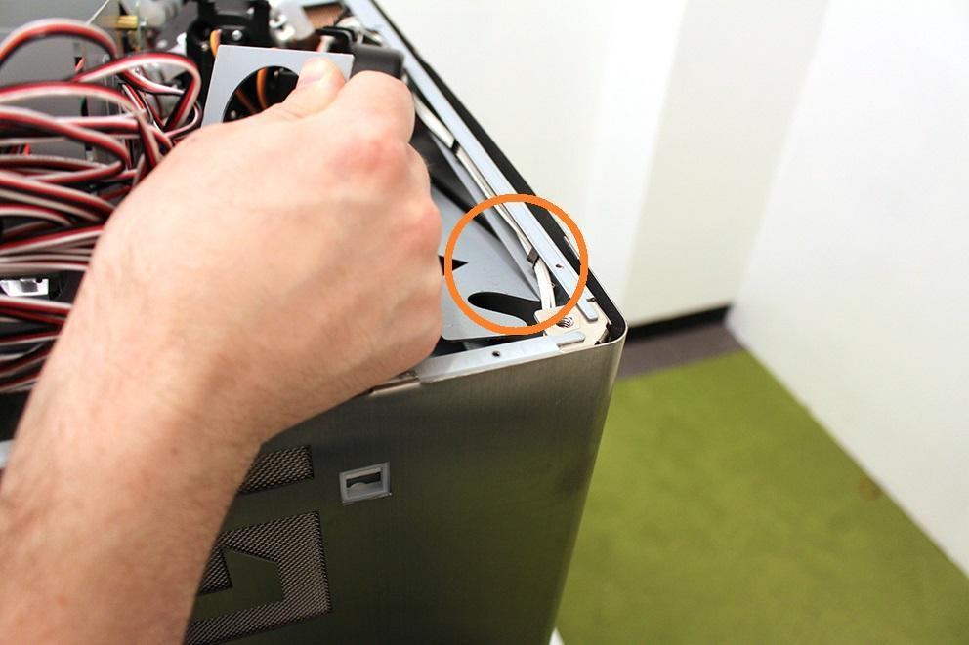

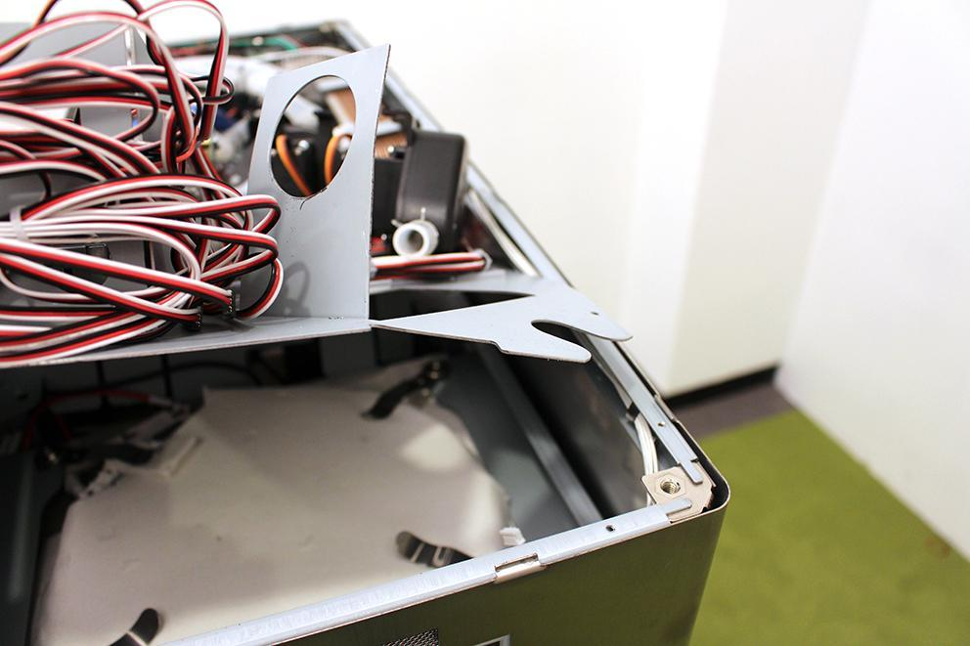

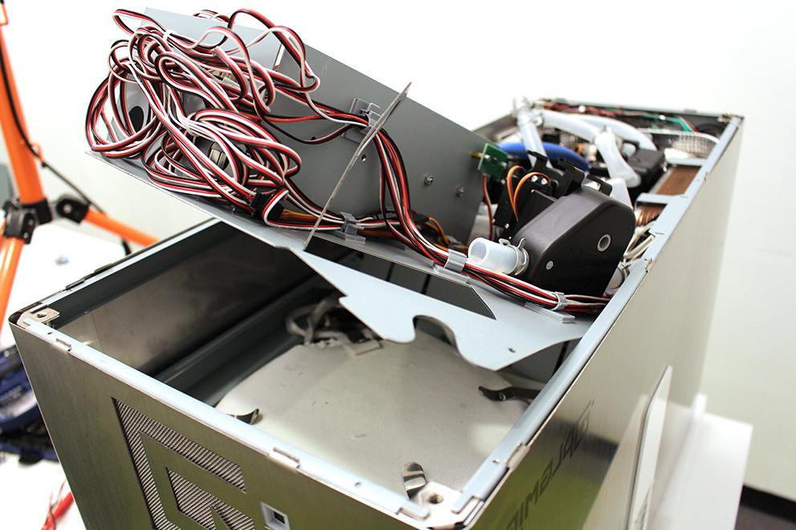

Rotate the 4 indicated heat plate clamps to free the heatplate.

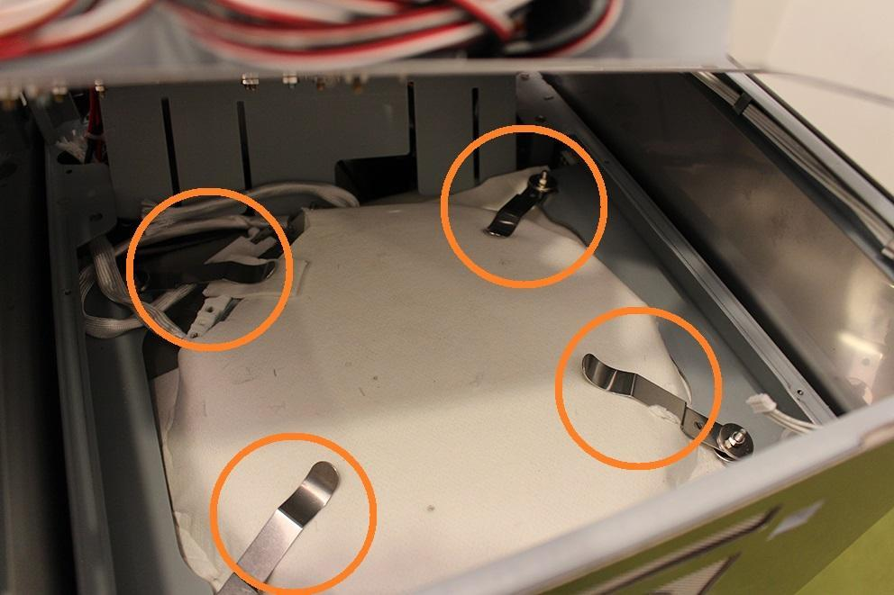

Remove the indicated heat plate cables.

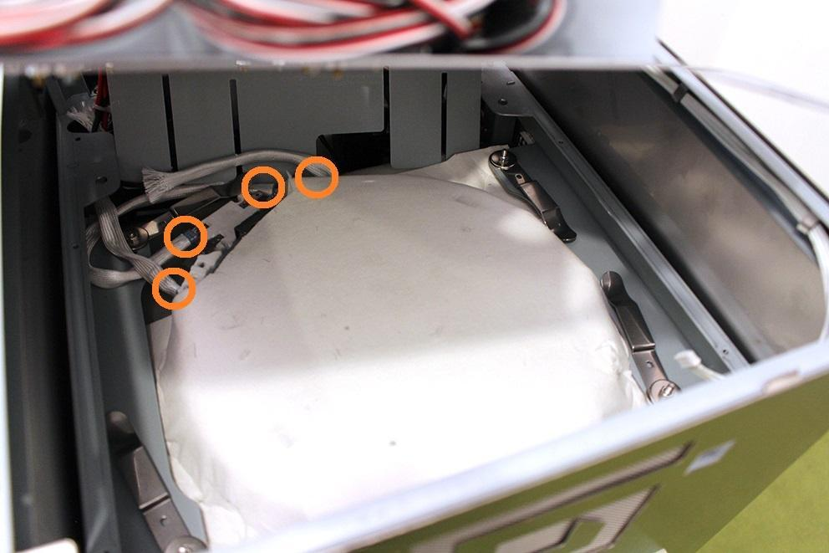

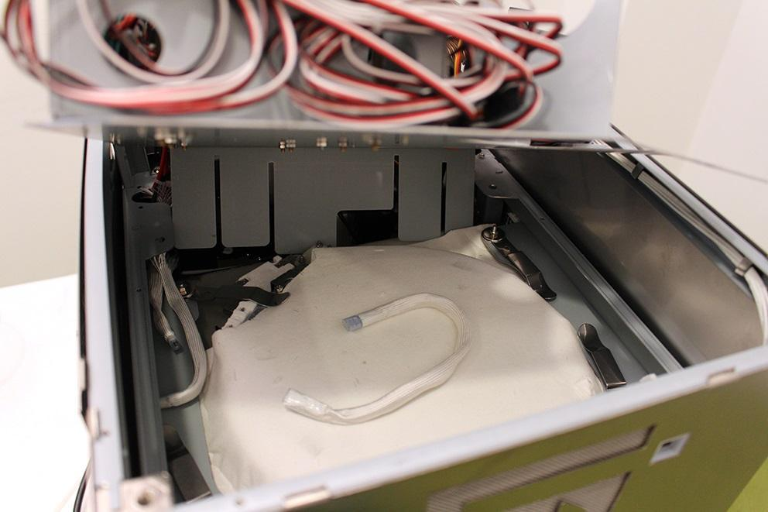

Remove carefully one side of the heat insulation.

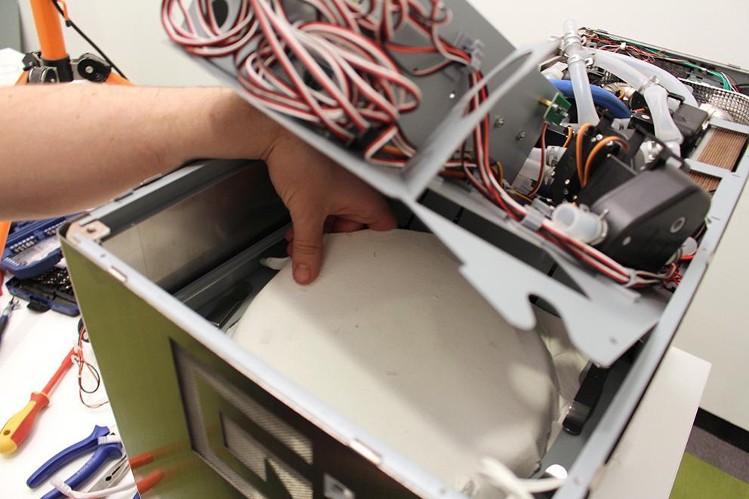

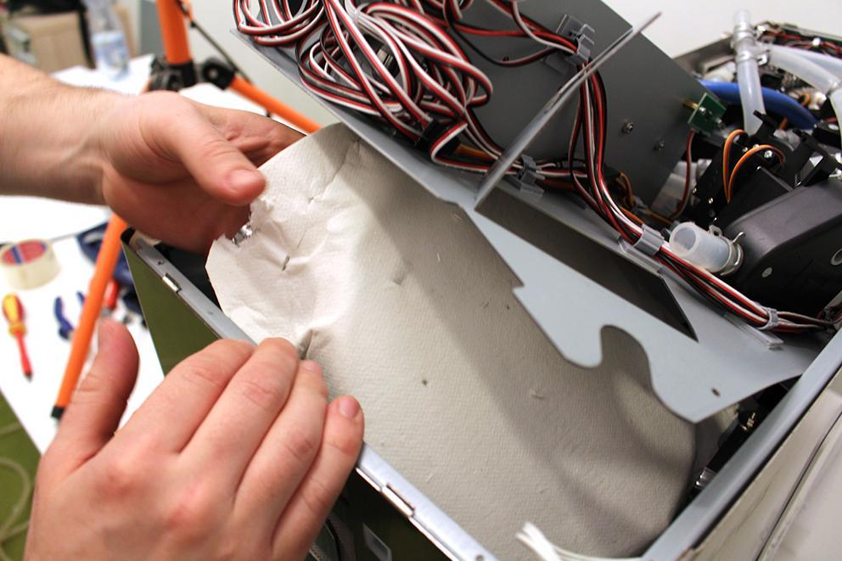

Now the heat plate can be removed.

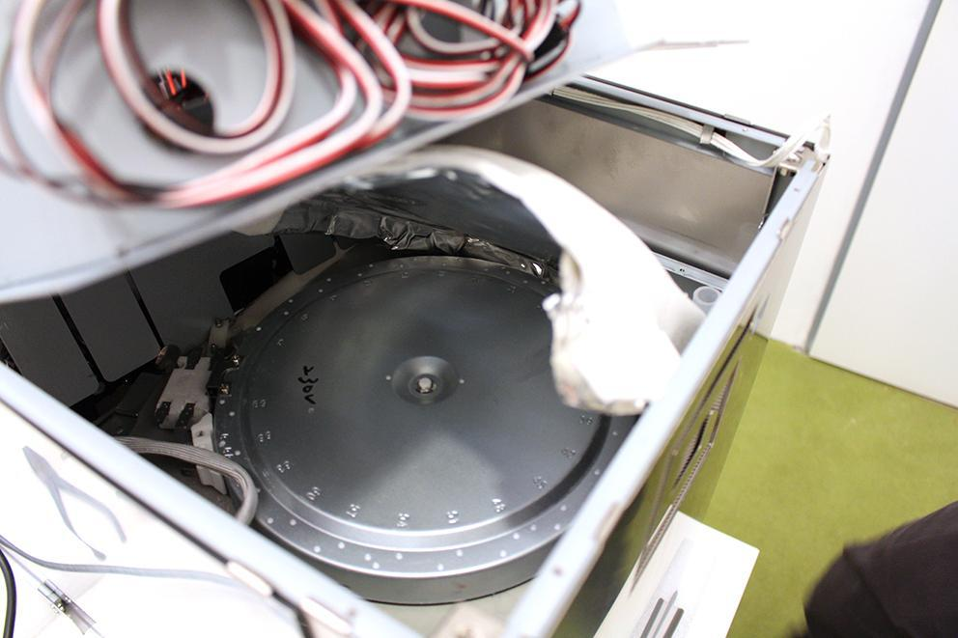

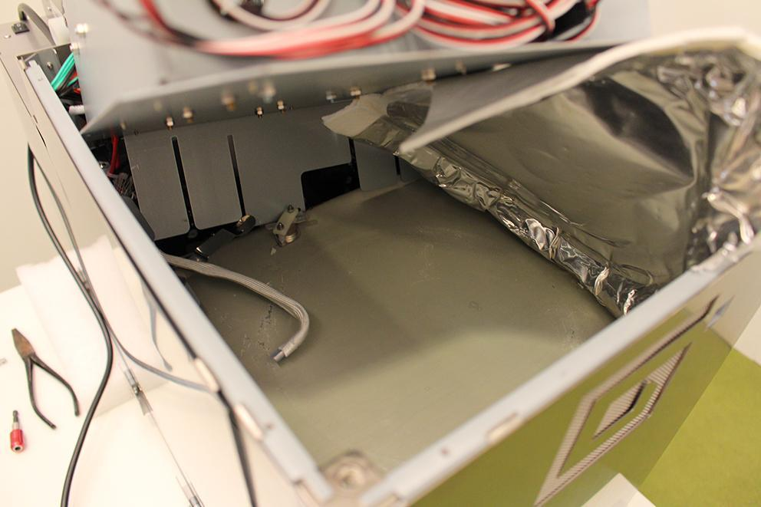

Remove the 4 indicated locknuts.

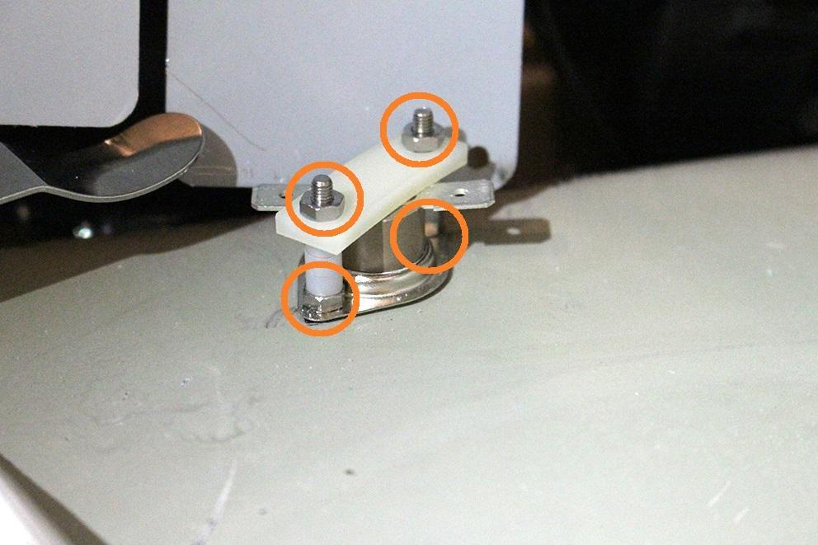

Now you can remove the part.

Reassemble consists of the same steps in reverse.

During reassembling, do not forget to place back the heat plate clamps!



Be careful not to crample the silicone flange around the button while reassembling the button!

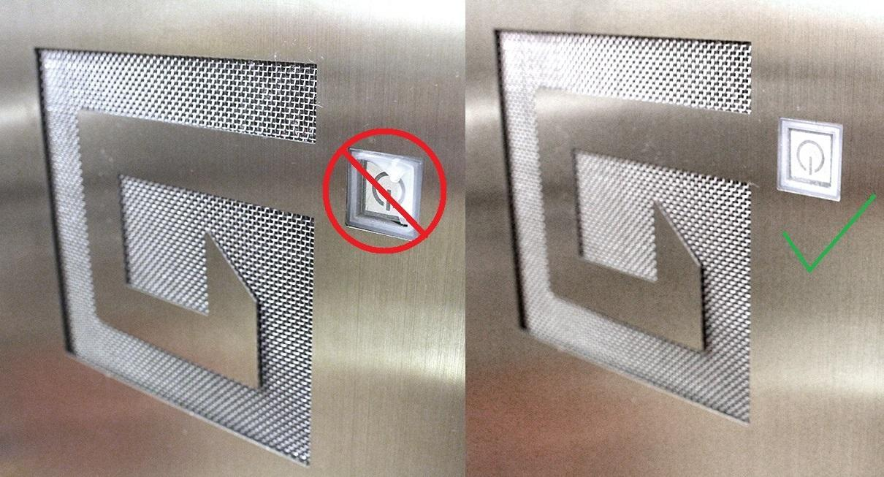

Make sure that the pumps are in the specified angle. Otherwise the pumps will not work properly. Use cable tie to fix the pump.

